HEALTH INSURANCE

1. The Normative question: Is Universal Health Care Desirable?
A. Limit adverse selection in insurance mkt.
B. Health care is expensive (even in countries that control costs) ⇒ Poor can’t afford health care on their own and need help
C. People face different health risks (i.e., pre-existing conditions) ⇒ Those facing high health risks face very high insurance costs in the private market. Should the government insure people for all health risks? Yes, if health risks are outside people’s control (e.g., age, genetics). Not necessarily if health risks are due to choices (e.g., relentless driving).
Con
Health care overconsumption (being free MC = 0…)

2. Universal Health Insurance
All OECD countries (except the US) gov. has huge role in providing public insurance. The government either directly controls doctors/hospitals or reimburses private health care providers and controls costs through Regulation (i.e., the government picks allowed treatments based on cost-effectiveness, bargains for prices, rations care in some cases) + The government limits healthcare overconsumption via Patient co-payments (i.e., patients share part of the cost)

3. The US healthcare system
A. Costs and results
a) US health care is very expensive: 17% of the GDP (super high) relative to 9% on average in other OECD countries.
Why expenditure so high? costs of treatments / pharma (ex. hip surgery, insulin etc)
---> Why costs so high? Basically healthcare in US is a very lucrative business + there are very high administrative costs
Insurance market: Very far from mkt competition, it is oligopolistic
As a consequence of very high costs a significant fraction of the population is uninsured (≃10%) -> Very poor results on life expectancy (way lower than in OECD)

B. The structure of the market
The US has a mix of public and private insurance:
a. Privately provided insurance (56%)
I. Employer-provided health insurance, 50%
Mandatory for large employers since Obamacare. Started after WW2. Employer-level insurance allows risk pooling across employees. But the cost has grown enormously ($15K/covered worker). Workers ultimately bear the cost in the form of reduced wages because employers care about total labor cost = wage + benefits.
II. Individual purchases (mostly Obamacare exchanges) on the Nongroup direct insurance market, 6%
In this markets you can buy insurance directly. No risk pooling --> The nongroup insurance market was not a well-functioning market before Obamacare due to adverse selection. Obamacare is changing the nongroup market drastically by forbidding pricing based on preexisting conditions (keep only age) and mandating health insurance (still mandatory but individual fines removed very fast, nonsense! ) pooling equilibrium with very high premium.
b. Government provided insurance (35%)
I. Medicare for the elderly (65+), 14% of the population.
Started in 1965 as a universal health insurance system for the elderly (65+) and nonelderly on disability insurance. Every citizen who has worked for 10 years (or their spouse) is eligible. Financed with an uncapped payroll tax of 2.9%.
II. Medicaid for the poor, 20% of the population
Provides health care for the poor (i.e., a means-tested benefit). Financed from general revenues by Federal and state governments. There are big variations across states in Medicaid generosity. 70% of recipients are mothers & kids, but 66% of expenditure goes to long-term care for the elderly/disabled.
Program eligibility criteria have been expanded over time (Obamacare). *an elderly can receive both Medicare and Medicaid, as different services are coveref
III. Other (mostly veterans benefits), 1% of the population
c. Uninsured
10% of the population (15-16% before Obamacare)

C. Obamacare (Affordable Care Act of 2010)
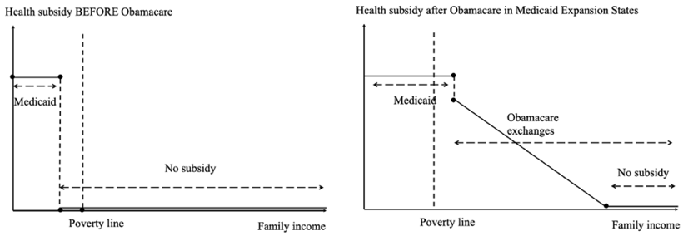
a. Features and Results
Problem: in 2013 17% uninsured. Funded primarily with a surtax on the rich. Features of Obamacare:
I. It bans pre-existing conditions exclusion and health-based pricing.
II. It forces individuals (and large employers with 50+ employees) to buy health insurance or pay a fine ( Individual fines dropped in 2019)
III. Expansion of Free or subsidized insurance for low-income families:
i. Free insurance: Medicaid expansion up to 138% of the poverty line
ii. Subsidized insurance: Subsidized health insurance purchases in Obamacare exchanges up to 400% of the poverty line. Basically Controlled prices + progressive subsidies on the online platforms where low income families can purchase health insurance.
uninured to 10%

b. Legal Challenges
Is the mandate constitutional? Ruling: Yes, but Feds cannot force States to expand Medicaid
⇒ Many states decided to opt out of the Medicaid expansion (even if the Fed government pays 90%!)
Consequence: There is a coverage gap because people below 100% of poverty cannot access subsidized Obamacare exchanges.

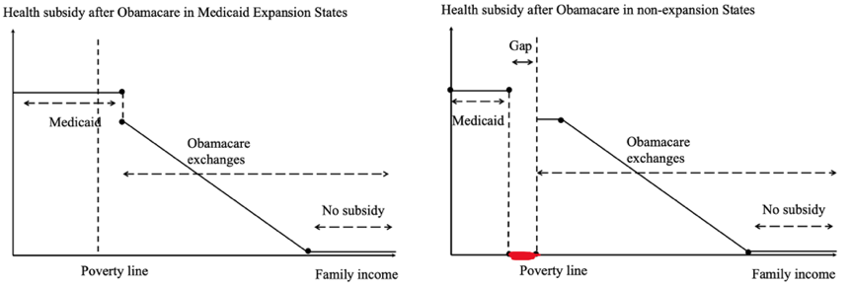

Results: Nice gains (less uninsured ppl) in states that adopted. States moving slowly to accept Medicaid expansion through referenda, 10 holdouts as of 2023.

D. Can US shift to public health care?
Key advantages: everybody is covered, government controls costs better, but requires a huge shift (doing away with the health insurance industry and employer coverage) Improving Obamacare starts from the existing system and patches the holes: nudge more states into Medicaid expansion, improve Obamacare exchanges (more subsidies, lower deductibles, public option, etc.).

4. General Research: Positive Effects of having Health Insurance
A. Finkelstein et al. (2012) use the lottery as an instrument to estimate the causal effect of insurance coverage itself
In 2008, Oregon had a limited Medicaid budget ⇒ Lottery to select individuals on the waitlist to be given a chance to apply for Medicaid insurance coverage.
⇒ 30,000 “lottery winners” (treatment group) out of 90,000 participants (control group)
Winning the lottery increases the probability of having health insurance by 29% (some losers took up insurance, some winners did not)
A. Intention to Treat (ITT): Just compare winners and losers of the lottery (yeah but not all winners take insurance, but just 29%)
B. Local Average Treatment Effect (LATE): Inflate estimates by 1/.29=3.5 (assume all have taken the insurance)
Results: Winning the Medicaid lottery leads to:
a. Higher health care utilization (including primary and preventive care as well as hospitalizations)
b. Lower out-of-pocket medical expenditures and medical debt (including fewer bills sent to collection agencies for unpaid debt)
c. Better self-reported physical and mental health (have doctors, drugs)

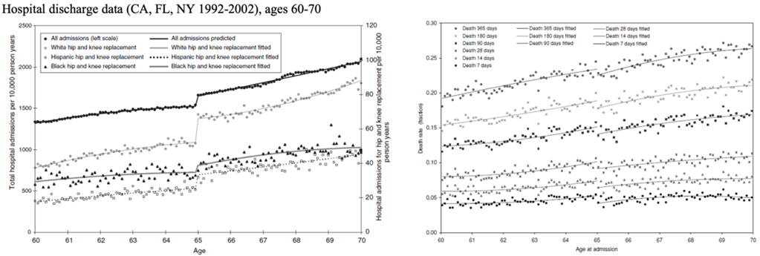
B. Card-Dobkin-Maestas QJE’09
Free Insurance Becomes available when you turn 65 --> Suggests a regression discontinuity design to see what happens when you cross the age 65 threshold.
Examines impacts on mortality following emergency hospital admission for individuals with diagnoses with the same admission rates before and after 65.
Compare 64 people to 66 people and look for outcomes (we know there is obviously a sharp increase in coverage).
Conclusion:
a. Big increase in healthcare utilization
b. Visible decrease in mortality after admission

5. Optimal Health Insurance: Analysis of the Provider Side
The preceding analysis of optimal insurance assumes the patient makes the entire healthcare decision. This assumed a passive doctor, in the sense that the doctor provides whatever treatment the patient requested. Clearly, the reality is closer to the opposite: docs choose treatment and may respond to financial incentives. Incorporating supply-side issues is critical in understanding health market. How should we design payment schemes for physicians? General equation for Physician compensation: P = a + b * c with a = fixed payment cost for a given diagnosis, b = payment for proportional costs. Then, two possibilities:
A. Retrospective payment schemes (fee-for-service): a = 0, b > 1
Physician compensation: P = b * c, *clearly different services may have different b
B. Prospective payment schemes (diagnosis-based fixed payments): a > 0, b = 0
Physician compensation: P = a, *clearly different services may have different a

Medicare/Medicaid shifted in the 1980s to a prospective payment scheme (To each diagnosis there is a given cost a, reimbursed by gov. )
--> Tradeoff: lower β incentivizes doctors to provide less services! ⇒ Lower costs, but complaints of lower quality of care
Cutler (1993) finds that PPS led to:
a. A reduction in treatment intensity (e.g., The average length of hospital stay for elderly patients fell by 1.3 days, huge decrease for pregnant women)
b. No adverse impact on patient outcomes despite the reduction in treatment intensity ⇒ Evidence that doctors put some weight on profits and were not only optimizing patient health
c. Cost growth slowed dramatically five years after PPS but then accelerated again.

6. Biggest failure of US health care: Opioid Epidemic
Late 1990s, big pharma pushed opioid painkillers aggressively Encouraged doctors to prescribe them (patients love them in the SR but often get addicted).
⇒ Led to misuse and addiction, then turned to heroin and fentanyl. The US now has 1.5m opioid addicts. 100K people/year die from overdoses in the US. 10 times more deaths than in the EU relative to the population.

